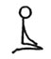 | 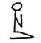 | 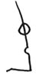 | 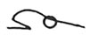 | 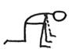 | 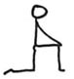 | 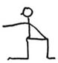
Inspir | Expir | Inspir | Expir | Inspir (droite) | Expir / Inspir | Expir (gauche)
 | 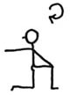 |  | 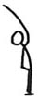 |  | 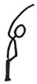
Inspir | Expir (droite) | Inspir | Expir (gauche) | Inspir | Expir (droite) | Inspir / Expir
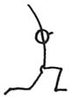 |  | 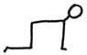 | 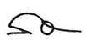 | 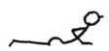

Inspir Expir Inspir Expir Inspir Expir
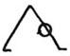

Expir D
Inspir
Expir
Inspir
Expir
Inspir
Expir

Inspir
Expir
Inspir
Expir

Inspir

Expir
Inspir

Expir
Inspir

Inspir/Exp
Expir G
Inspir
Inspir

 |  |  |  | 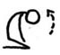
 |  | Expir | Inspir

